**Real system setting and raw data collection**

**1, Communication method between distributed system**

The main work of this quarter is to find a efficient communication method between pods. Considering the difficulties of time arrangement in data transmission to set up our own sockets between clients and server, we applied an existed communication protocol called: Message Queuing Telemetry Transport (MQTT). MQTT is a extremely lightweight publish/subscribe machine-to-machine (M2M) connectivity protocol. Instead of setting up dialog directly between server and clients, there is a broker functioning as a data distributor. The basic structure of the MQTT protocol is shown as:

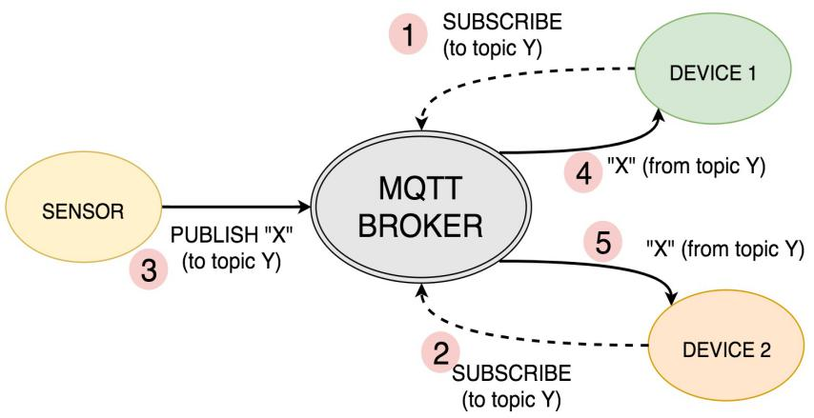

Figure 1 MQTT structure

In our system, we have several pods work as the sensor in figure 1. Similar with the youtuber publish video on their own channel, pods have their individual fixed channel assigned in the broker and will update the distance information in that specific channel. Since channels are independent from each other, no data will be lost as long as the transmission rate is higher then the single pod refreshing rate. In other words, the amount of devices connected in to the system will not influence the data updating.

Also, we will have a subscriber(main raspberry pi) who subscribe all these channels. Once the publisher update their status, the subscriber will receive a new piece of data. Because there is no fixed role in this protocol, the subscriber can also work as a publisher as well. Such kind of flexibility enable the main raspberry pi publishing command to all pods.

In our set-up, the refreshing rate for each ToF sensor is approximately 3Hz.

**2, set up the real system in LESA suite**

We installed 12 pods on the ceiling of LESA suite.

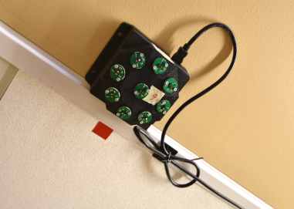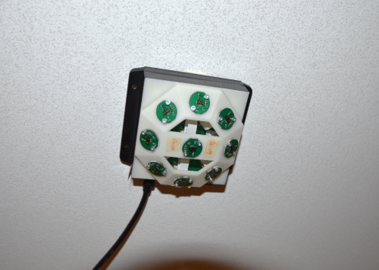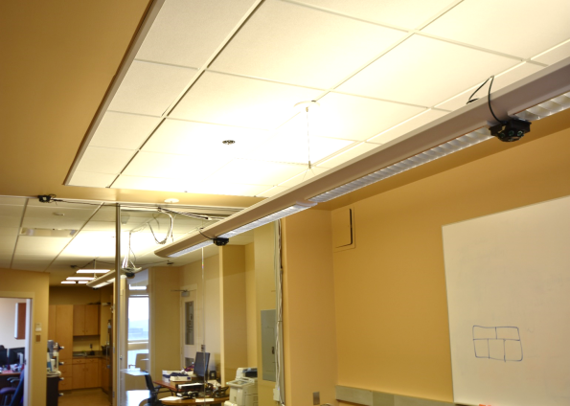

Figure 2 LESA suite installation with pod of different type

As it is shown in figure 2, due to the layout of the light, the pods are installed at different height. To compensate for the shrink of detection range caused by lower installation, we applied larger angle pods (). And at each entrance, we use  pods in order to have a higher accuracy. The following image shows how pods are distributed:

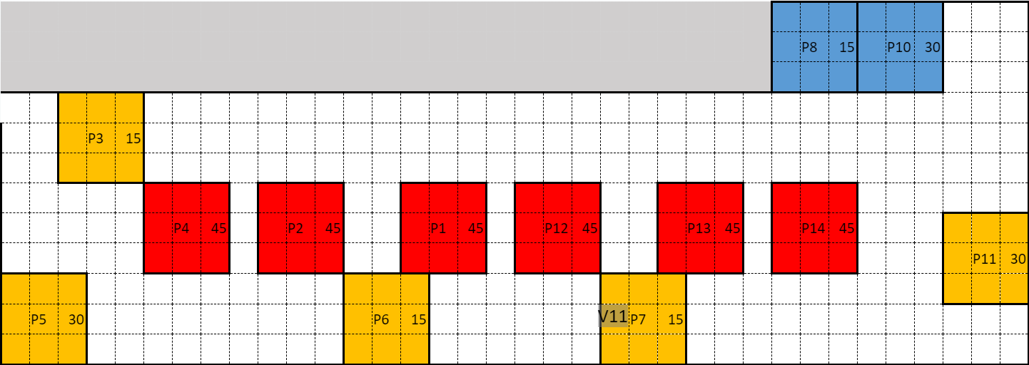

Figure 3 Pods Installation

Red represents the lowest height, the yellow means the normal ceiling height and the blue means higher than normal ceiling. Since every pod has 9 ToF sensors on it, so the reading values can be filled into a 3 by 3 window.

**3, Real time data collection and visualization**

Base on the pods installation in figure 3, we did the real time test

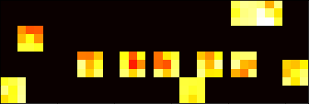

Figure 4 Real test visualization

Figure 4 is the real time data visualization with the background. The background include some tables and chairs in the suite. When a shorter distance is detected, the corresponding pixel will appears more reddish. So the real time visualization appears as we expected. Then I did several experiment to test the performance of detecting moving person.

There is a video of real test when a person walking in a counter-clockwise direction. In this video, the background is kept. The link to the video: https://www.dropbox.com/s/ua5n2nv3qzfabk2/night_1.mp4?dl=0

There is also a video without the background:

https://www.dropbox.com/s/h8lrln251kj09of/night_fg.mp4?dl=0